June 18, 2013

To whom it may concern:

This letter is to unconditionally endorse and recommend Mr. Tim Ronacher as an ideal person for employment to any company he chooses to work for. I can speak not only to his high moral character, but to his excellent work ethic, as well.

I’ve known Tim since he was in middle school as one of a number of school chums of my daughter and continues to be. Tim worked for me, helping with yard work and other odd jobs, including house/dog sitting while we traveled on a number of occasions. He has proven himself, to me as trustworthy, loyal, friendly, intelligent, self-motivated, dependable and undaunted by adversities in life. Instead of dropping back and quitting when hit with a problem. I watched as Tim would immediately think through whatever issue he faced and find a way through it, over it, under it or around it.

When my wife passed away at a young age, Tim and his brother walked several miles late at night to our house and when no one was around, created an artful collage of specific sentiment about things my daughter’s mom had done for and with him and his friends over the years they knew her, demonstrating how much she had affected their lives, growing up. This was done in chalk on our drive way. It was so large and included such detail; I had a hard time photographing the entire creation.

As to his work ethic, on jobs he did for me, he worked hard and smart. When he was done with one thing, he was back, immediately, asking what else needed to be done. That is, if he had not already figured out on his own what needed to be done. He didn’t just do the job, he did it completely and then some. He’s always willing to put extra into everything he does.

I realize that some of this may seem a very glowing list of accolades for such a young man. On the contrary, it is just who Tim is. More importantly, it’s what he has made of himself, growing up in a large, single parent family.

As a Manager, myself, I have seen Tim make personal sacrifices and choices that are developing a character that will make him stand out, as an older adult, in a generation that seems to expect entitlements as opposed to making something of oneself.

You could expect nothing less of a person whose personal emails, since I have known him, have included a tag line that reads, “The kid who is NEVER down!”

Sincerely,

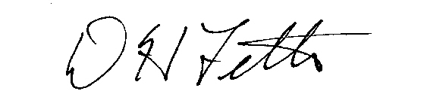

DH Fetter

